## Adding an EBS volume

1. Determine availability zone of the instance/server in AWS
2. Create the EBS vol in that zone
3. Run lsblk to see the new drive
4. Format the drive with a file system
5. Create mount directory
6. Mount formatted ebs vol to mount directory
7. Register the mount poin to etc fstab to keep it from dropping off.

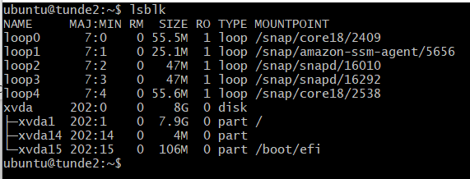Before new ebs vol addition after attaching vol.

My server availability zone: us-east-1b (us-east Virginia)